Electrical Overview

Year: 2025 Semester: Fall Team: 9 Project: Fairway Finder

Creation Date: February 3rd, 2025 Last Modified: February 8, 2025

Author: Marcus Good Email: mrgood@purdue.edu

Assignment Evaluation: See Rubric on Brightspace Assignment

Electrical Overview

Distance measurements from multiple ultrasonic sensors will be transmitted to the MCU for obstacle avoidance. To connect the user’s phone to the robot a low energy Bluetooth module will be used to transmit & receive data. The Bluetooth data will consist of movement commands from the user and robot status information (e.g. battery percentage, robot velocity, location etc.) will be sent to the user’s phone. A GNSS module will be used to track the robot’s position. H-Bridge motor controller modules will be used to control the speed and direction of the DC motors. A 12VDC battery with a management system will used as the power source for the system. It will communicate battery status (charge level, voltage, current draw etc.) to the MCU. A USB port at 5VDC will be used as the power source when the battery is not connected or the MCU is being programmed. Buck converters will be used to step the 12VDC battery voltage (or 5VDC from the USB) down to 3.3VDC and 5 VDC respectively. 3.3VDC will be used for the microcontroller and 5VDC will be for the ultrasonic sensors. Two 12V geared DC motors will be used to move the robot. Finally, the group expects to use a 32-bit STM microcontroller (MCU) for all computation on the robot. The microcontroller will be calculating the position difference between the user’s phone location and the robot. Then it will issue movement commands to the motor controllers to travel to the given location. This will be based on the differences in coordinates of the user’s and robot’s locations. The MCU will also run an obstacle avoidance algorithm that will use the ultrasonics distance measurements and GNSS location to ensure the robot does not collide with anything. Finally, an app on the user’s phone will allow for manual motor control commands to be sent over Bluetooth to the robot.

2.0 Electrical Considerations

Operating Frequencies

The default baud rate of 115200 Hz for the GNSS UART sensor will be used. The CC2541 will operate at 9600 Hz as that it is default value. For our purposes these default rates are sufficient to communicate location data between the GNSS module and the MCU, as well as information from the Bluetooth module to the MCU. The default MCU frequency for the STM32F746ZG of 216 MHz is also sufficient for all computational needs regarding robot movement & power stability & obstacle avoidance. As long as the user gets responsive feedback from the robot over the mobile app nothing within our project requires extremely quick processing/response times.

Power Budget & Tolerances

# | Component | Function | Qty | Voltage | Avg. Current | Max  Current | Max Power (W)
1 | A58SW31ZY, Geared DC Motors | Movement | 2 | 12VDC | 1.6A | 5A | 60 W
2 | HC-SR04 | Distance measurement/obstacle avoidance | 4 | 5VDC | 15 mA | 20mA | 0.4 W
3 | CC2541 Bluetooth Low Energy Module  (HM-10 breakout board) | Movement commands & location from user. Robot status & location sent to user. | 1 | 2-3.6VDC | 18mA  (Tested at 3VDC) | 20.2mA  (Tested at 3VDC) | 0.061 W
4 | SAM-M8Q GNSS Module | Location tracking of robot and user | 1 | 3.1-3.6VDC | 32mA | 67mA | 0.22 W
5 | STM32F746ZG | Microcontroller | 1 | 3.3VDC | 165mA | 230mA | 0.759 W

Table 1: Power Consumption Table

Voltage (VDC) | Avg. Current Consumption | Max Current Consumption | Avg. Power Consumed (W) | Max Power Consumed  (W)
12 | 1.6A | 5A | 19.2 | 60
5 | 60mA | 80mA | 0.3 | 0.4
3.3 | 215mA | 315.4mA | 0.71 | 1.04
 |  | TOTAL POWER | 20.21 | 61.44

Table 2: Power Tolerances

Electrical Loading Considerations

Based on these tolerances above the AP63203’s up to 2A output at 3.3VDC and AP63205’s up to 2A output at 5VDC are more than sufficient [5]. The DRV8874 motor driver can handle up to 6A continuous current which is sufficient for the A58SW31ZY DC motor [4]. The BLF-1203AB 12VDC battery max continuous output current of 7A also meets the 5A maximum stall current of the DC motor and all other maximum loads at the lower 5V and 3.3V DC voltage levels at once [7]. Overall average power consumption of 20.21W will last 1.78 hours with a 12V, 3 Ah battery. This assumes the motors are going as fast as possible for the entire 1.78 hours. Worst case power consumption of 61.44W will last 35.4 minutes with the same battery. This assumes the motors are achieving their stall current the entire time. The runtime will be longer than these values as the device will not be running full speed during the entire time the user is playing golf. A power switch that will send the MCU & all electrical components into standby mode will be used to ensure the robot’s storage time is as long as possible. Finally, a kill switch will be built into the power network to physically open the power connections (using relays) after the 5VDC input from the USB port and 12VDC input from the batteries. This will instantly remove power from the robot.

3.0 Interface Considerations
# | Interfaces | Uses | Data Rate
1 | USB | Programming STM32 MCU  Non-battery power supply to robot | 48 MHZ
2 | UART | Bluetooth module data I/O  GNSS module data I/O | Default 115200 b/s baud rate  CC2541 (9600 b/s baud rate)
3 | GPIO | Component enable signals  Interrupts/power switches | Up to 108 MHZ (Data rate depends on purpose)
4 | Barrel Plug | 12VDC battery charging | N/A (DC voltage only)

Table 3: Interface Overview

Interface Usages Description:

USB: Allows an external computer to program the STM32F746ZG MCU using the ST-link. It will allow the team to upload, debug, and communicate with the microcontroller. When the 12V battery is disconnect it will provide power to all 5V loads and become an input to the 3.3VDC buck converter.

UART: Permits all data to be communicated between the Bluetooth module and the microcontroller. The GNSS module will also transmit the robot’s location & all other necessary information to the MCU on this interface.

GPIO: Enable signals for the MCU to turn on and off certain electrical components on the PCB. The robot power switch and motor controller status information. Finally, to send the pulse waveform back and forth from the MCU to the ultrasonic sensors. This will give us our distance measurement data.

Barrel Plug: Easy power connection & disconnection between the battery and charger.

4.0 Sources Cited:

[1] STMicroelectronics, STM32F746ZG: Arm® Cortex®-M7 32-bit MCU Datasheet, Rev. 6, Feb. 2017. Available: https://engineering.purdue.edu/477grp9/Files/refs/stm32f746zg.pdf. [Accessed: Feb. 6, 2025].

[2] u-blox, SAM-M8Q Data Sheet, Rev. 1, Jan. 2016. Available: https://engineering.purdue.edu/477grp9/Files/refs/SAM-M8Q_DataSheet__UBX-16012619_.pdf. [Accessed: Feb. 6, 2025].

[3] Texas Instruments, CC2541 SimpleLink™ Bluetooth® Low Energy and Proprietary Wireless MCU Datasheet, Rev. D, Jun. 2013. Available: https://www.ti.com/lit/ds/symlink/cc2541.pdf. [Accessed: Feb. 6, 2025].
[4] Texas Instruments, DRV8874: 36-V, 3.5-A Brushed DC Motor Driver With Current Regulation and PWM Control, Datasheet, Nov. 2020. [Online]. Available: https://www.ti.com/lit/ds/symlink/drv8874.pdf. [Accessed: 08-Feb-2025].
[5] Diodes Incorporated, AP63200/AP63201/AP63203/AP63205: 2 A, Synchronous Buck Converter, Datasheet, Oct. 2020. [Online]. Available: https://www.diodes.com/assets/Datasheets/AP63200-AP63201-AP63203-AP63205.pdf. [Accessed: 08-Feb-2025].
[6] BRINGSMART, Geared 12VDC Motor Datasheet, [Online]. Available: https://engineering.purdue.edu/477grp9/Files/refs/DCmotor.png. [Accessed: 08-Feb-2025].
[7] BLF-1203AB User Manual, Rev. 04, 23 Mar. 2019. [Online]. Available: https://cdn.shopify.com/s/files/1/0219/0154/files/BLF-1203AB_User_Manual_rev_04_23_2019.pdf?208. [Accessed: 8 Feb. 2025].

Appendix 1: System Block Diagrams

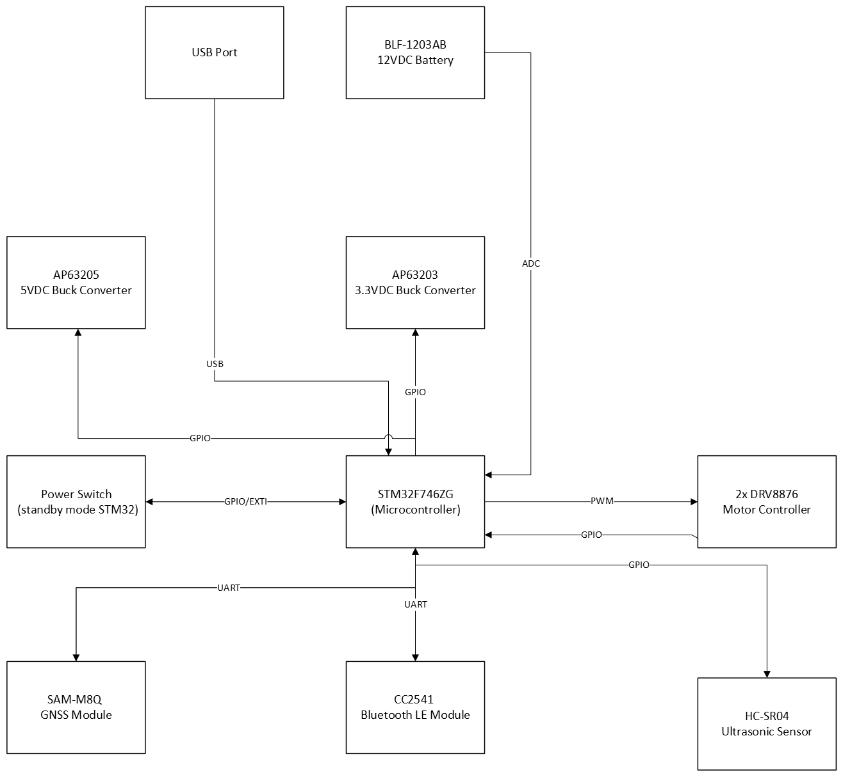

Figure 1: System Block Diagram

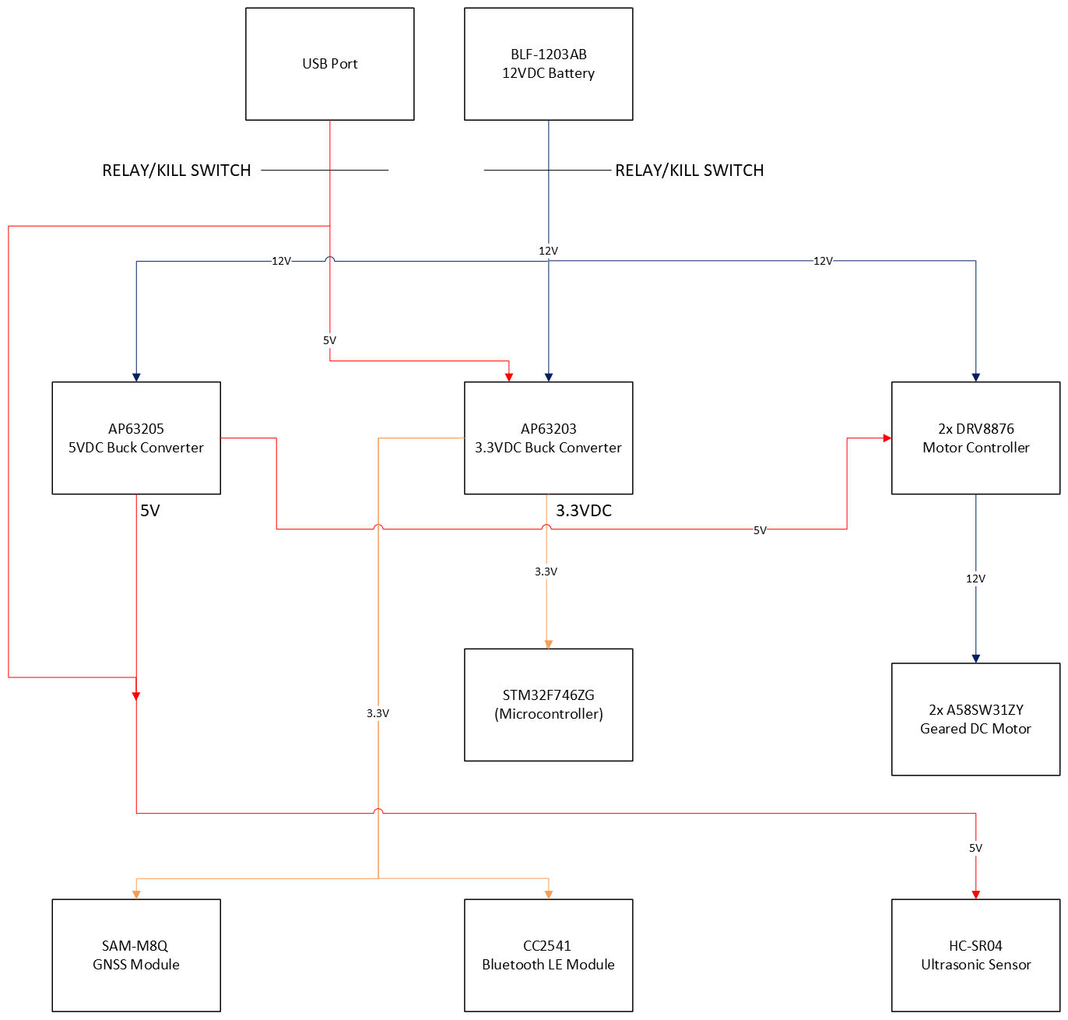

Figure 2: Power Network

